# Section: 16-3: The Eighteenth Vassa & Nineteenth Vassa (Age 52 & 53)

In Section 16-1, we explored how the Buddha spent his thirteenth rainy season in the tranquil heights of **Mount Cāliya** (Cāliya Pabbata). According to ancient sources and commentaries, he later chose this very place again for his eighteenth and nineteenth vassas. Perhaps the solitude and serenity of the Cāliya Hills drew him back to this favoured retreat.

While we previously discussed the possible location of this significant site, we were unable to reach a definitive conclusion due to the lack of scriptural and historical evidence. Based on geographical factors, we speculated that the ancient Cāliya Hills might have been located in present-day Jharkhand, near the Bihar border—an area that was once part of the Magadha Kingdom. Interestingly, **the Gautam Buddha Wildlife Sanctuary**, in Bihar-Jharkhand with its low hills, abundant rivers and lakes, marshy lands and lush forests, aligns with the descriptions of the region. This led us to consider the possibility that the ancient Cāliya Hills may have been situated within this natural landscape. However, due to the absence of clear references to Cāliya Pabbata in modern maps, this remains an open question. (See Section 16-1 for background information)

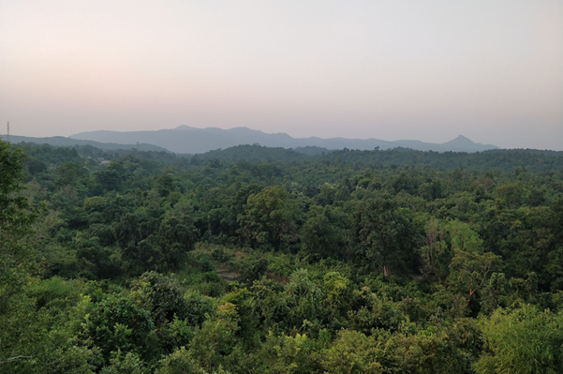

**Serene hilly grove of Gautam Buddha Wildlife Sanctuary, in Bihar-Jharkhand [1]**

**Note:** The Gautam Buddha Wildlife Sanctuary is located in Gaya district of Bihar state and Koderma district of Jharkhand state in east-central India. This wildlife sanctuary was established in 1976 and covers an area of 259 km. Prior to becoming a wildlife protected area, the area was a private hunting reserve. This sanctuary covers portions of the Lower Gangetic Plains most deciduous forests and Chota Nagpur dry deciduous forests ecoregions. [2]

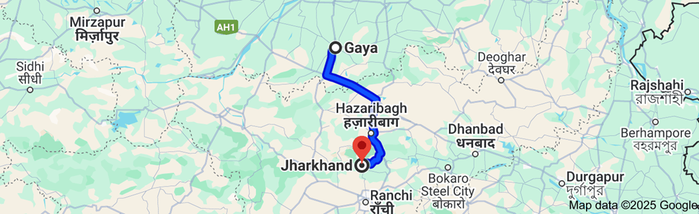

**Map showing location of Gautam Buddha Wildlife Sanctuary. Distance from Gaya to Jharkhand is 191.9 km [3]**

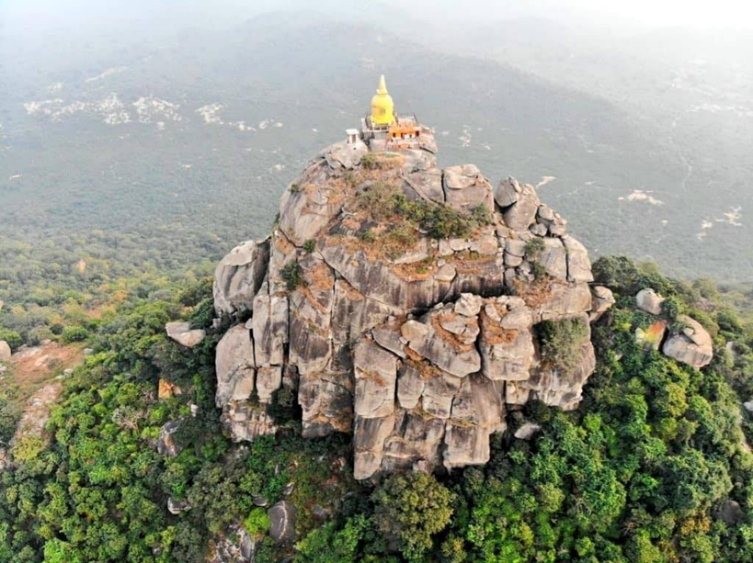

**Hill top Shrine surrounded by rolling hills and lush green groves in Gautam Buddha Wildlife Sanctuary [4]**

**Note:** According to Buddhist commentaries, Cālikā was both the name of a city and a nearby mountain where the Buddha resided. A large monastery was built at the site, where the Buddha was sustained by the generosity of the local people. [5]

## Location Where the Buddha spent these two rainy seasons

As the scriptures do not provide many details about the locations where the Blessed One resided during these two rainy seasons, we must rely on other sources to fill in the gaps.

### According to other sources:

1) “The eighteenth on mount Cāliya and then also the nineteenth” [6]

2) “Aṅgīrasa, having slain the terrible stain of passion in the world with the sweet, pleasurable Dhamma-medicine, in the eighteenth Rains Retreat, dwelt on Cāliya mountain. The sweet-voiced Protector of the World, the Noble King of Dhamma, after slaying with the sword of the Dhamma the great enemy delusion in the responsive people and kinsmen, in the nineteenth Rains Retreat, again dwelt there (on Cāliya mountain).[7]

3) “ The Buddha stayed for two continuous *vassa* (namely the eighteenth and the nineteenth) at the Cāliya mountain monastery with Jantu village, in the Caliya country, serving as His alms-resort” [8]

## Significant Event Happened before the commencement of the eighteenth vassa

The Dhammapada commentary relates the following story based on a verse spoken by the Buddha, illustrating how hunger can be an obstacle to spiritual development.

### The Buddha’s Compassion for a Poor Farmer

According to the commnetry this event happened before the commenecment of the eighteenth vassa:[9]

On one occasion, the Buddha perceived that a poor farmer from Āḷavī was ripe for realization. Moved by compassion, he journeyed to Āḷavī to teach him. That day, the farmer had lost his ox and spent hours searching for it. When he finally found it, he remembered that the Buddha was in town and, despite his exhaustion and hunger, hurried to see him without taking any food.

Meanwhile, in Āḷavī, the Buddha and his monks had received their meal offering, but the Buddha refrained from giving thanks until the farmer arrived. Upon seeing the weary man, the Buddha did something unprecedented—he asked that food be given to him before teaching the Dhamma. Only after the farmer had eaten and regained his composure did the Buddha deliver his discourse. With a clear and receptive mind, the farmer attained Stream-entry.

That evening, the monks reflected on this unusual event. Never before had the Buddha personally requested a meal for a householder. Understanding their thoughts, the Buddha explained:

*"Hunger is the greatest affliction. Had I preached to him while he was weak with hunger, he would not have grasped my words. There is no suffering like hunger."*

Then he recited this verse:

**"Hunger is the worst illness,**  
**Conditions are the worst suffering.**  
**For one who truly knows this,**  
**Nibbāna is the highest happiness."** (Dhp:203)

The monks listened with deep contemplation. The Buddha elaborated that while physical ailments may be cured for days, months, or even years, hunger demands constant attention—it is the most relentless of all sufferings. Even greater, however, is the suffering caused by conditioned existence itself, the ceaseless cycle of craving and becoming. True freedom, he declared, lies only in the peace of Nibbāna, which, unlike fleeting worldly happiness, is unshaken and enduring.

By the end of the discourse, many monks attained noble realization, deepening their understanding of the Dhamma.

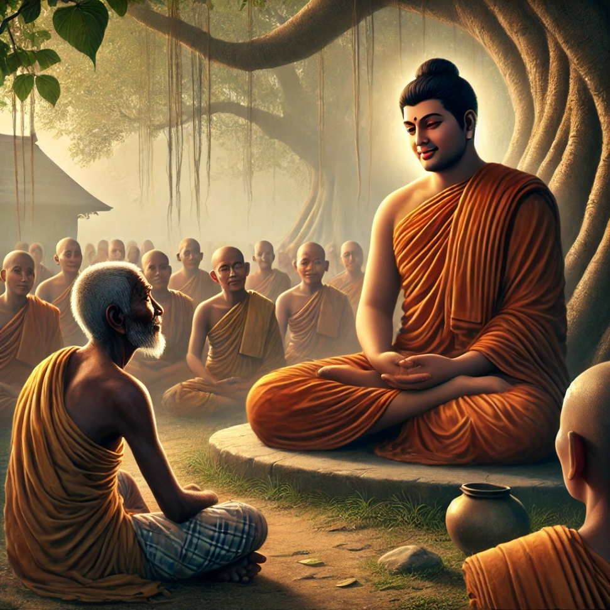

**The Blessed One Teaching to the Poor Farmer who was fotunate to become a stream winner [10]**

## Benefits of Living Solitude in Forests Groves

The Scriptures does not provide specific records of the Buddha’s teachings during these two rainy seasons where he lived in a thick forest grove. However, throughout his life, the Buddha consistently emphasized the profound spiritual benefits of solitude in remote forest dwellings, guiding his disciples toward deeper meditative development. He also elucidated the significance of his own association with these tranquil retreats, highlighting their role in fostering wisdom and inner peace. Since the Buddha chose to reside in such secluded places during this period, we find it fitting to reflect on his reverence for forest abodes. To illustrate this, we have presented the following suttas, which illuminate his deep appreciation for solitude and the spiritual refuge found in nature.

### Why Did the Buddha Seek Solitude in the Deep Forest?

The Blessed One himself revealed the profound purpose behind his preference for remote forest dwellings:

*“Bhikkhus, seeing two advantages, I resort to secluded lodgings in forests and jungle groves. What two? For myself, I find a peaceful abiding in this very life, and I have**compassion for**future generations. Seeing these two advantages, I choose to dwell in the solitude of the wilderness.”[11]*

The Buddha’s deep compassion extended beyond his own lifetime. By embracing the forest life, he set a timeless example for those who would follow the path. He showed that even one who had already reached the ultimate goal—having nothing left to understand, abandon, develop, or realize—still found value in dwelling in solitude.

Thus, when young seekers, inspired by faith, witness that the Fully Enlightened One himself did not neglect the forest life, they, too, are moved to cultivate the same discipline. In following his footsteps, they hasten their own liberation and swiftly reach the end of suffering.

The Buddha’s life was not only a teaching in words but a living testament to the path of renunciation, serenity, and ultimate freedom. His choice to abide in the wilderness was both a personal refuge and an enduring act of compassion, illuminating the way for all who seek the highest truth.

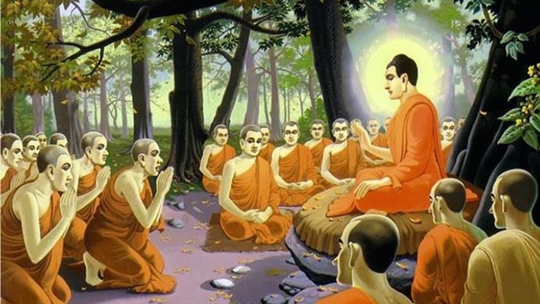

**Buddha consistently emphasized the profound spiritual benefits of solitude in remote forest dwellings, guiding his disciples toward deeper meditative development [12]**

### Who Are the True Forest Dwellers?

In this Sutta (AN 5:181), the Blessed One clarifies who can truly be called a forest dweller and who cannot. He describes five types of individuals who take to the forest:

1. The dull and foolish – One who retreats into the forest due to ignorance and lack of wisdom.
2. The lustful – One who enters the forest, not out of renunciation, but because of being driven by unwholesome desires.
3. The mentally unstable – One who seeks the forest due to confusion, delusion, or madness.
4. The one motivated by praise – One who becomes a forest dweller simply because it is lauded by the Buddhas and their disciples.
5. The true renunciant – One who chooses the forest life for the sake of fewness of desires, contentment, the elimination of defilements, solitude, and simplicity.

The Blessed One likens these five types to the progressive refinement of dairy products: from milk to curd, from curd to butter, from butter to ghee, and finally, to the supreme cream of ghee. Likewise, among these five, the one who dwells in the forest for the sake of true renunciation and simplicity is the highest, the most excellent, and the most worthy of honour.

This teaching reminds us that renunciation is not defined merely by physical seclusion, but by purity of intention. The true forest dweller is not simply one who lives among trees but one who has left behind craving, delusion, and attachment, dwelling in the forest with a heart inclined toward wisdom and liberation.

### Suitable Conditions for Dwelling in Forest Groves to Enhance the Spiritual Path

In the Vanapattha Sutta (MN: 17), the Buddha provides guidance on when a meditative monk should continue residing in a jungle thicket and when he should seek a more suitable place. The decision is based on two key factors: progress on the spiritual path and the availability of requisites necessary for survival.

The Buddha advises:

1. If a monk is not making progress in his spiritual practice and struggles to obtain basic requisites, he should leave that place.
2. If a monk is not making spiritual progress but has an abundance of requisites, he should also leave.
3. If a monk is progressing well in his practice but finds it difficult to obtain requisites, he should endure and stay.
4. If a monk is making good spiritual progress and has sufficient requisites, he should remain in that place.

Thus, the forest should be a place that nurtures both meditative development and basic sustenance—if it fails to support either, the monk must wisely seek a more conducive environment.

### Who Is Fit to Live in a Remote Forest Grove?

In the Aṅguttara Nikāya (AN 4:262), the Blessed One further clarifies the qualities that determine whether a bhikkhu is suited for living in the solitude of the forest.

A monk unfit for forest dwelling possesses four unwholesome tendencies:

1. Sensual thoughts – His mind is still entangled in sense pleasures.
2. Thoughts of ill will – He harbors resentment and anger.
3. Thoughts of harming – His mind inclines toward cruelty rather than compassion.
4. Lack of wisdom – He is dull, lacking insight and discernment.

On the other hand, a monk fit to live in the wilderness has cultivated four noble qualities:

1. Thoughts of renunciation – His mind is free from attachment to worldly pleasures.
2. Thoughts of goodwill – He radiates compassion and loving kindness *(karuna and metta)*
3. Thoughts of harmlessness – He is gentle and compassionate toward all beings.
4. Wisdom – He possesses discernment and clarity of mind.

This teaching underscores that living in solitude is not merely about physical seclusion but about mental refinement. The forest can be a powerful aid on the path, but only for one whose mind is untainted by defilements and firmly established in wisdom, kindness, and renunciation.

### Further Advice on Dwelling in Remote Forest Groves

On one occasion, Venerable Upāli approached the Blessed One, paid homage, sat respectfully to one side, and said: (AN:10:99)

*“Bhante, I wish to dwell in remote lodgings, deep in the forests and jungle groves.”*

With great compassion, the Buddha cautioned him:

*“Upāli, dwelling in remote forests and jungle groves is difficult to endure. Solitude is challenging to undertake and hard to find joy in. If a bhikkhu does not develop deep Samadhi, the solitude of the wilderness can unsettle his mind”*

*“ It is to be expected that one who says, ‘I have not yet gained samadhi, yet I will resort to remote lodgings in the forest,’ will either sink or be swept away. He will sink due to sensual thoughts or float away due to thoughts of ill will and harming.”*

To illustrate his point, the Blessed One offered a simile:

“Suppose, Upāli, there was a vast lake, and a mighty bull elephant came along. Thinking, ‘Let me enter this lake and playfully wash my ears and back; I will bathe, drink, and go wherever I please,’ he steps in. Because of his great size, he finds solid footing in the depths, bathes with ease, and moves freely as he wishes.

Then, a hare or a cat comes along. Seeing the bull elephant, it thinks, ‘How is he any different from me? I too will enter this lake, wash my ears and back, bathe, and drink as I please.’ But without reflecting, it hastily plunges into the deep waters—only to be either dragged under or carried away by the current.

Why? Because its small body cannot find footing in the depths.

So too, Upāli, if one who has not yet attained Samadhi seeks to dwell in remote forests and jungle groves, it is to be expected that he will either sink or be swept away.”

#### Insight from This Teaching

The Buddha’s compassionate advice highlights that **seclusion is not merely a matter of external solitude but requires inner stability**. Just as a mighty elephant can navigate deep waters while a small creature is easily overcome, a bhikkhu with **strong Samadhi and wisdom** can thrive in the solitude of the forest. However, one who is **not yet grounded in meditative discipline** may find himself overwhelmed, unable to withstand the mind’s unchecked wanderings.

Thus, before seeking the deep solitude of the forest, one must first establish a **firm footing in Samadhi and insight**, ensuring that solitude becomes a support for the path rather than a source of danger.

With that profound advice from the Blessed One we will end this section. In the next section (17-1), we will examine where the Buddha spent his twentieth vassa.

### End Notes: Section 16-3

1. Source: <https://www.wildbihar.org/gautam-buddha-bird-sanctuary>
2. Ibid.
3. Google map.
4. Source: <https://www.facebook.com/GayaFD/videos/watch-a-beautiful-eco-cultural-tourism-site-in-gautam-buddha-wildlife-sanctuary-/4015327725152440/>
5. See: AN: Notes: 1830.
6. Source 1: Madhuratthavilāsinī (Buddhavaṁsatthakathā) of Bhadantâcariya Buddhadatta Mahathera: Translated by I. B. Honer, 1946.
7. Source 2: Jinacaritaṁ, The Life of the Victorious Buddha, translated by Bhikkhu Anandajoti.
8. Source 3: Chapter 34: The Great Chronicles of the Buddhas by Venerable Mingun Sayadaw.
9. Source: A Revised Translationof the Dhammapada Aṭṭhakathā together with a New Translation of All the Verse Texts E W Burlingame, Ānandajoti Bhikkhu
10. AI generated image.
11. AN2:30
12. Source: <https://sinhalatipitaka.wordpress.com/page/18/>